A000-US-OH-Adams Co.-Platform Pipe-Sterling, IL. Pipestone-Hopewell-500 BCE-100 CE**.**

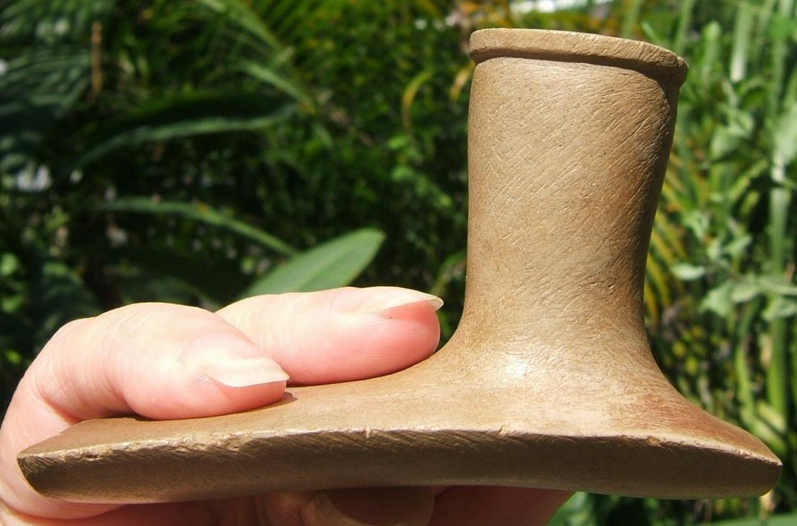

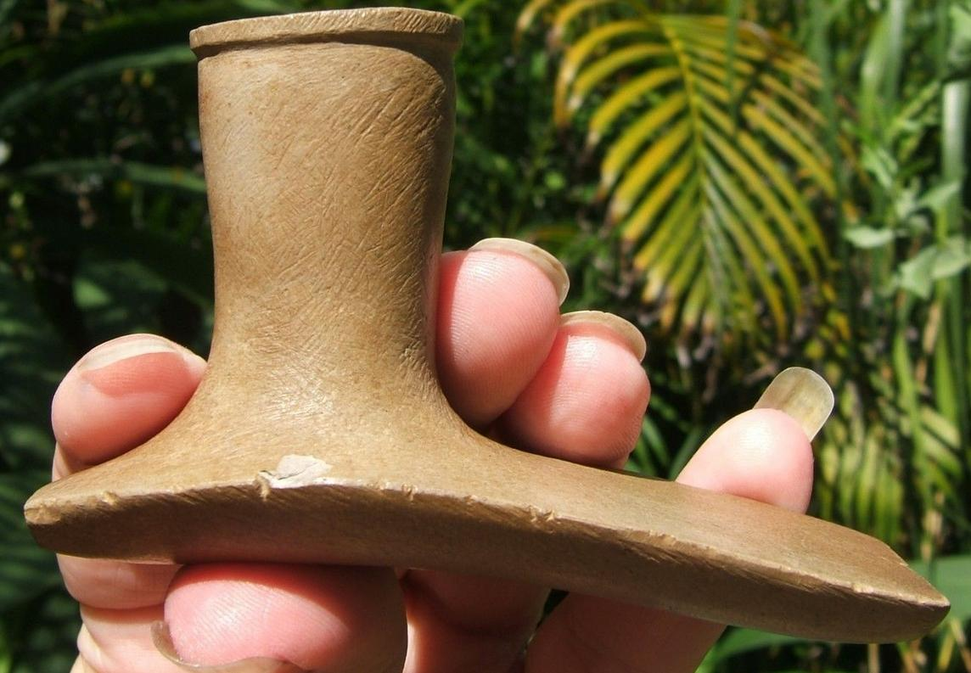

Figs. 1-2. US-OH-Adams Co.-Platform Pipe-Sterling, IL. Pipestone-Hopewell-500 BCE-100 CE

Case no.: 11

Accession Number:

Formal Label: US-OH-Adams Co.-Platform Pipe-Sterling, IL. Pipestone-Hopewell-500 BCE-100 CE

**Display Description:**

Large Hopewell Platform Pipe made of Sterling, IL. Pipestone Found in Adams Co.,Ohio. Ex Francis Patton collections. Tom Shenk COA.

**Hopewell platform pipe from Adams County, OH; of Sterling, IL. Quarries Pipestone**

**LC Classification: E99.H69**

Date or Time Horizon: 500 BCE-100 CE

Geographical Area: OH-Adams Co

**Map:**

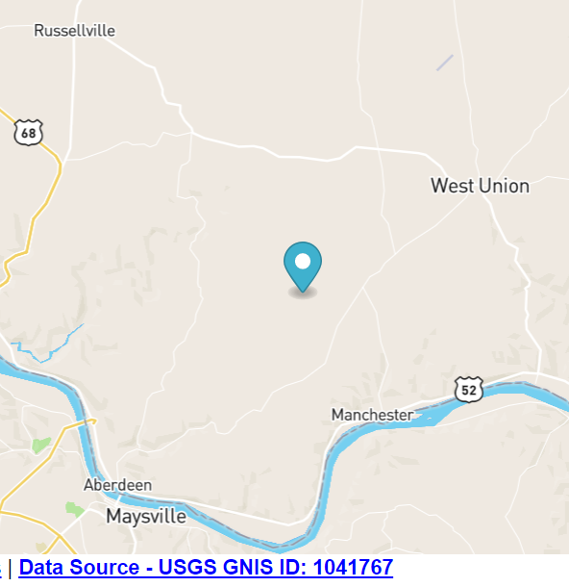

**GPS coordinates: Lat** 38.7433986, Long -83.650192

Cultural Affiliation: Hopewell

Medium: Gray Pipestone, Sterling, IL.

Dimensions: L: 3 ¾ in.; W: 1 ¾ in.; H: 2 in.

Weight:

Condition: original

Provenance: [lynnscollectibles](http://www.ebay.com/usr/lynnscollectibles?_trksid=p2057872.m2749.l2754)

**Discussion:**

**References:**

Appendix: Order Hidden

|  |  |
| --- | --- |
| ORDER DATEApr 11, 2016 | ORDER TOTAL  US $425.00 Estimate $700.00.  Free shipping  **Order 3 3/4" Museum Quality Hopewell Platform Pipe** [Leave feedback - ORDER DATE Apr 11, 2016](http://feedback.ebay.com/ws/eBayISAPI.dll?LeaveFeedbackShow&useridto=lynnscollectibles&transactID=1506477204001&item=111947891960&_trksid=p2057872.m2749.l2665)[View order details](http://payments.ebay.com/ws/eBayISAPI.dll?ViewPaymentStatus&transId=1506477204001&itemid=111947891960&_trksid=p2057872.m2749.l2673) - ORDER DATE Apr 11, 2016  [More actions - ORDER DATE Apr 11, 2016](http://www.ebay.com/myb/PurchaseHistory) |

1 item sold by [lynnscollectibles](http://www.ebay.com/usr/lynnscollectibles?_trksid=p2057872.m2749.l2754)

|  |  |  |
| --- | --- | --- |
| [3 3/4" Museum Quality Hopewell Platform Pipe](http://www.ebay.com/itm/111947891960?_trksid=p2057872.m2749.l2649&ssPageName=STRK%3AMEBIDX%3AIT)  ( 111947891960 )  Delivered on Thu, Apr 14  Tracking number: [**Tracking number**9505514162116103228013](javascript:;)  [Add note](javascript:;) | ITEM PRICE:  US $425.00 |  |